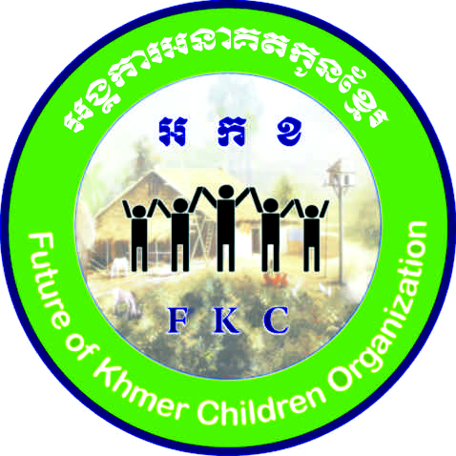
GgÁkarGnaKtkUnExµr

Future of Khmer Children Organization (FKC)
(DONATION)
Please fill this out and e-mail to us so we know
what you would like to support
RURAL COMMUNITY (FAMILY SUPPORT)
Description |  | Cost price | Quantity | Amount
Fresh water well to village (Pipe) |  | $ 550.00
Fresh water well to village (Iron) |  | $ 350.00
Water storage unit |  | $ 100.00
Water filter |  | $ 50.00
Toilet |  | $ 750.00
Cow |  | $ 500.00
Bag of rice 50 kg (inc. Fish sauce, soya sauce, Fish canned) |  | $ 50.00
Family package(Rice, Soya, Fish sauce, mosquito net, shampoo) |  | $ 75.00
Bicycle |  | $ 55.00
Set of Chickens (9 female and 1 male) + chicken feed (1 pack) |  | $ 50.00
Piglet |  | $ 75.00
EDUCATION SUPPORT TO THE STUDENTS
Bicycle for students |  | $ 55.00
Backpack |  | $ 10.00
School supplies(1 set) |  | $ 8.00
Students Uniform for kids from $11 - $13 depending on size |  | $ 11.00+
Pair of flip-flops / shoes |  | $ 8.00
Weekly meal support (on Sunday for 70 students at FKC school) $1.50 for 1 person |  | $ 105.00
Weekly transportation from the village school to FKC (dance training) |  | $ 15.00
Basic medical supplies (1 set) |  | $ 40.00
Sewing machine for vocational training |  | $ 195.00
Monthly support for school children living in the family (Community) |  | $ 35.00
Monthly Sponsor of Kids from grade 1-6 (6-12 years old) 1month, 1 person |  | $ 20.00
Monthly Sponsor of Kids from grade 7-9 (13-17 years olD) 1month, 1person |  | $ 30.00
Monthly Sponsor of Kids from grade 10-12 (18-21 years old) 1 month, 1person |  | $ 40.00
Note:
If you sponsor a water well make sure you let us know what you want on it.
If you have clothes, toys or anything you do not use, we would happily have it donated here!
 | Signature of donor
 | Name:
 | Many thanks for your help!

